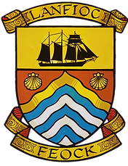
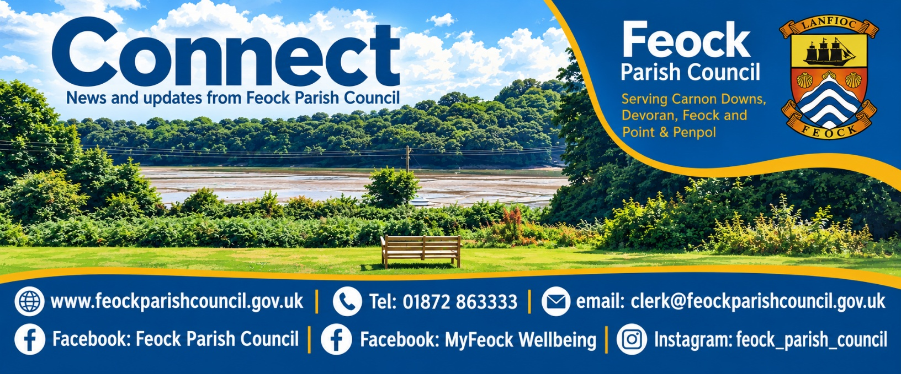
Welcome to the Parish Council latest news update – November 2026
Welcome to Connect, Feock Parish Council's newsletter bringing you the latest news, updates and community information from across Carnon Downs, Devoran, Feock and Point & Penpol. Whether it's Parish Council news, local projects, upcoming events, volunteering opportunities or information about services and activities in our community, our aim is to keep residents informed, connected and involved in parish life. Now we are moving in to winter this newsletter has lots of information about our Community Emergency Plan and how you can prepare for emergencies such as adverse weather and powercuts which we hope will be useful.

Connect is circulated regularly by email throughout the year, ensuring you receive timely news and updates as they happen. In addition, every household receives a printed annual edition each March, providing a round-up of the year's activities and information for all residents.

If you would like to receive our free electronic newsletter, along with the MyFeock What's On event guide, simply email myfeock@feockparishcouncil.gov.uk and we'll add you to our mailing list.

We look forward to keeping you up to date with everything happening in our wonderful parish.
Loe Beach Sale - Asset of Community Value application update
Following a significant number of requests and contact from the community, the Parish Council passed a resolution at their meeting on the 12th October 2026 to apply to Cornwall Council to register Loe Beach as an Asset of Community Value.
This application has now been submitted to Cornwall Council and we await their decision, this is likely to take between 6 to 8 weeks.
The Parish Council thanks residents for their input and helping to gather evidence of use for the application.
We will post on our website when the outcome of the application is known.
You can find out more about this process on Cornwall Council’s website https://www.cornwall.gov.uk/people-and-communities/cornwall-devolution-deal/community-right-to-bid/
Neighbourhood Priority Statement (NPS)
Feock Parish Council is working jointly with Kea Parish Council to prepare a Neighbourhood Priorities Statement (NPS) which will inform Cornwall Council’s new Local Plan that it is currently writing.

As part of the statutory process, Cornwall Council is carrying out a public consultation on the proposed Feock and Kea Neighbourhood Area Designation. This application does not affect parish or settlement boundaries, it is purely an application to secure permission from Cornwall Council for Feock and Kea Parish Councils to work together to produce a joint Neighbourhood Priority Statement. The Parish Councils felt that a joint NPS would be stronger, especially as Kea and Feock are similar parishes and face similar planning challenges.

Please see the information below on how you can submit your comments on this consultation, details also available at this link
https://planning.cornwall.gov.uk/online-applications/applicationDetails.do?activeTab=summary&keyVal=TML2EJFG1SK00

Once the Neighbourhood Priority Statement has been drafted, the public will be consulted and public events held to seek your views on the contents of the draft statement.

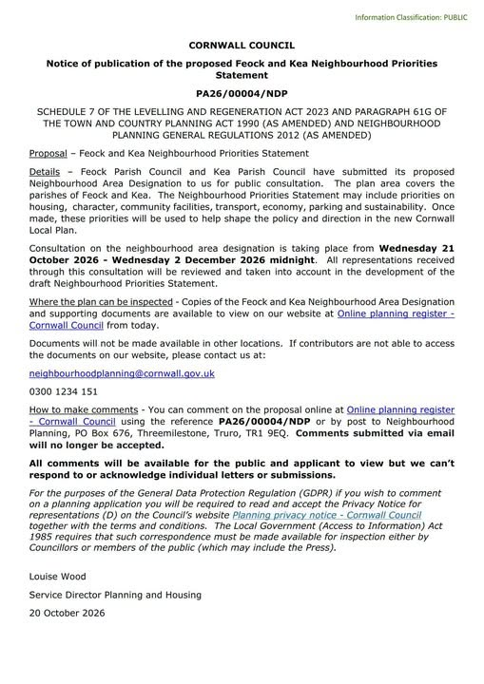
Small Grants Scheme Funding
Do you have an idea that could make a positive difference in our parish?

Feock Parish Council's Small Grants Scheme is designed to support local community groups and organisations that are based in, or work within, the parish. For the coming financial year, the Parish Council has allocated £2,000 to help fund projects that benefit our community.

Through MyFeock, the Parish Council's wellbeing initiative, we are keen to support activities that bring people together, improve wellbeing, and enhance the social and leisure opportunities available to parish residents.
Grants of up to £200 per organisation are available.

So far this year the Parish Council have been pleased to be able to support Devoran and Carnon Downs Village Halls, Market Street Christmas Lights in Devoran, Carnon Downs Bowling Club and Carnon Downs Christmas Lights. We look forward to supporting projects that make a real difference in our community.

Full guidance, eligibility criteria and application forms can be found on our website. Alternatively, contact Cathy by emailing myfeock@feockparishcouncil.gov.uk or calling 01872 863333, and she'll be happy to help.

Feock Community Emergency Plan

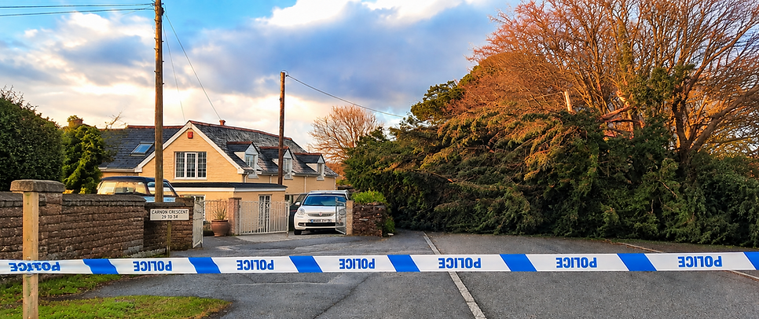
​
The Parish Council has started to put together a Parish Community Emergency Plan to be activated in events such as adverse weather, a lengthy power cut, trees down blocking road access etc. to provide help to residents if the Emergency services’ response is delayed.
​
We have now produced a Community Preparedness leaflet (copy available later in this newsletter) to help residents be prepared for an emergency and ensure they have things ready like battery torch, battery radio, water, food that doesn't need cooking etc. Of course every household will be different depending on ages of occupants and their needs but the leaflet provides a starting point for what a kit could look like.
​
So you can be more prepared in the event of a similar emergency in the future the Government also have advice on their Be Ready pages https://beready.campaign.gov.uk/

We are currently working with volunteers at the Emergency Hubs on the support they may be able to provide and when they might need to be open and hope that if there is another emergency we will be in a position to open them to support local residents.

If the emergency hubs are opened we will do our best to communicate this to residents via online methods such as our Facebook and our website and Radio Cornwall but it would also be helpful if residents could help spread the word to those not online or on social media who may be in need of support during an emergency.

We have such an amazing community who pull together during emergencies but don’t forget to check in on your neighbours, especially if they are vulnerable or elderly.

A list of emergency numbers is also available on our noticeboards and on our website
https://www.feockparishcouncil.gov.uk/emergencyplan

If you would like to volunteer to help out in an emergency please get in touch with Debra Roberts, Parish Clerk on 01872 863333 or email clerk@feockparishcouncil.gov.uk to be added to our list of volunteers.

The Priority Services Register
The Priority Services Register (PSR) is a free service across England, Scotland and Wales that gives extra support to customers who may need it.

This includes help if your electricity, gas or water supply is ever interrupted. This helps make sure you receive the right support from your energy and water companies when you need it most.

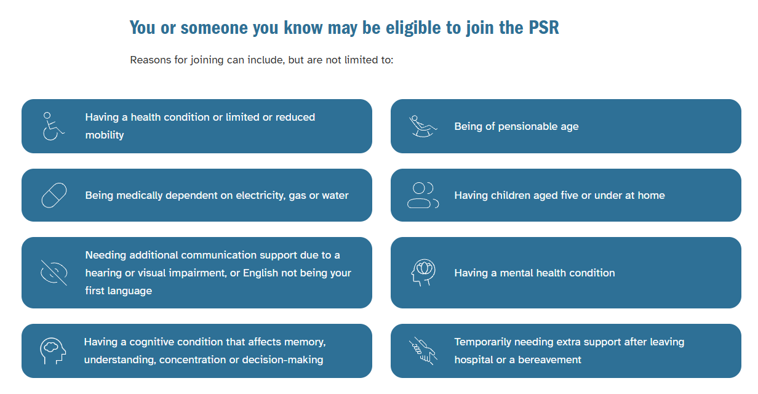

It’s easy to join the PSR
It only takes a few minutes to join the PSR. You can register through National Grid by going to this link:
https://customer.nationalgrid.co.uk/advice-and-guidance/priority-services or phone 0800 032 8301

Your details can then be shared with the other utility companies, so you don't need to register with each organisation.

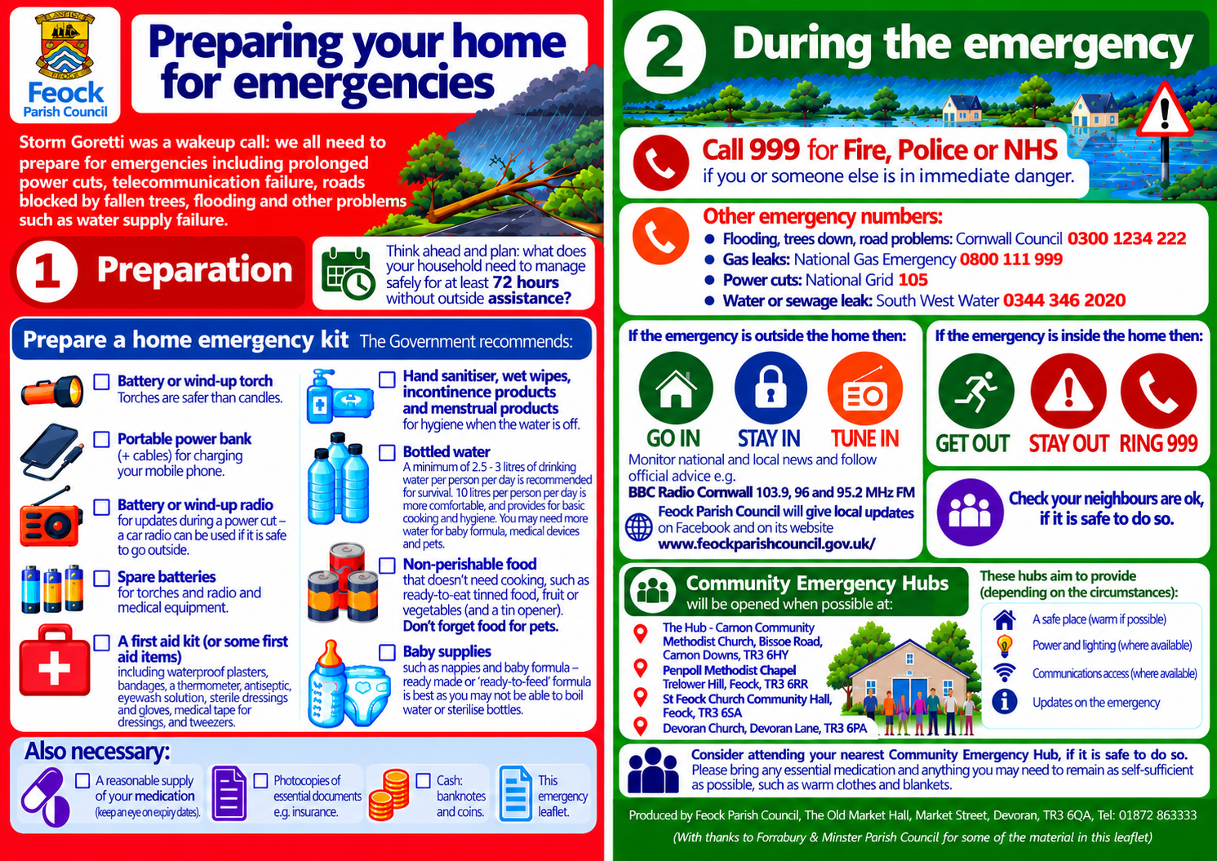

A Tale of Two Oysters by Cllr Phil Allen
Many will have noticed a new character spreading along our shoreline in recent years, unfortunately the presence of the alien invasive Pacific Oyster may seriously spoil your trip to the beach as its sharp crenulated shell is no friend to bare feet. The lacerations caused may bleed profusely and heal slowly.

How has this come to pass and what does the future hold?

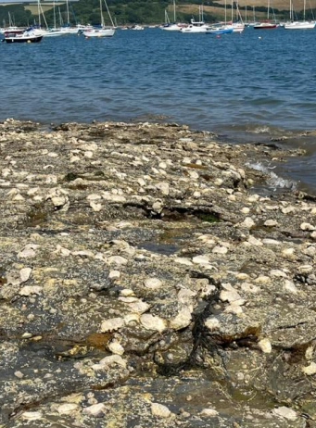
Pacific Oysters at Porthgwidden – July 2024

Where did the Pacific Oyster come from?
Magallana Gigas is native to the east coast of Asia naturally ranging from the Gulf of Thailand to Russia. It grows rapidly and has a sweet creamy flavour, which first prompted it being introduced to the western seaboard of North America and Canada in the early 1900s to support of their burgeoning oyster industry. At this time research indicated that ideal conditions for spawning were 20 to 25 degrees centigrade however the species could spawn naturally at a sea temperature above 16 degrees, so well suited to their new home in Canada. Europe followed the American's example with introductions into French waters in the 1960s and into our local waters the following decade. The introduction of “farmed oysters” in the UK proceeded under Government advise that sea temperatures were too cold for Pacific Oysters to reproduce. This proved not to be the case and, what is termed “feral oysters” now populate the majority of the UK coastline from Cornwall to the Shetland Isles. Pacific Oysters are classified as an alien invasive species with the caveat that they also provide “a beneficial resource for aquaculture”. In 2021 twelve Pacific Oyster farming operations were recorded in Devon and Cornwall. Whilst predominantly these operations grow their oysters in bags raised from the seabed on trestles, escape of spawn is common, creating feral colonies in the local area. Researchers have documented three phases of feral oyster infestation, the first may cover some decades of relatively slow introductory spread, at some point this is followed by a period of rapid accelerating growth, until a final phase which is characterised by the Pacific Oyster's natural adaptation towards reef creation. In this phase Pacific Oysters fully smother the foreshore floor and grow one on top of each other building a raised reef structure, quite unlike our own native oyster. In the Fal the second phase has been progressing over the last decade and the final phase of reef building can now be seen on many beaches. It is at this stage that the consequences of Pacific Oyster invasion become widely appreciated and the issue changes from being one of academic debate, into a problem and growing risk to environmental biodiversity and the safety of public enjoying recreation on our waterside.

What is being done and what can be done?
In 2021 Natural England first published its report, a “Partnership led strategy to monitor and manage the spread of Pacific Oyster populations in South Devon and Cornwall”. The report documented the work carried out by volunteers since 2017 and led locally by the Cornwall Wildlife Trust CWT. This work programme focussed on surveying the spread of Pacific Oysters in the Fal and Helford and assessing the effectiveness of control measures. Local volunteer groups included the Restronguet Creek Society, Ladies who Launch (Mylor Yacht Club) and the Falmouth Marine Conservation Group FMCG.

The report emphasised increasing concern over the feral spread of the oysters since 2016 and it documented the significant changes to the natural marine environment in the local area as a consequence. The CWT were particularly concerned to assess potential adverse effects on their seagrass restoration programme. Concern was also registered over the safety of beach users together with predicted damage to maritime craft and infrastructure, which has been experienced around the south coast and Europe in areas more advanced in
infestation. The work carried out by volunteers demonstrated that management interventions can be effective in mitigating the most severe risks and the report recommended that funding be made available for more coordinated effort which it said would deliver notable economic and environmental benefits within the affected areas. While Government at all levels is considering what action to take, local volunteers continue to battle the tide, a very recent survey organised by the FMCG recorded and culled over 6,000 oysters within a small zone at the mouth of Pill Creek. This ongoing work is vital in maintaining data base records, however the current level of effort cannot save the Fal from irrevocable change.

The Fal's natural oyster fishery:
The Fal oyster, Ostrea Edulis, has been harvested from neolithic times and, in common with those of other estuarine fisheries in the UK, provided a staple food throughout the ages. In the 17th century the oysters from Falmouth Haven were recommended " for their bigness, they having the biggest pulpe and substance". During the 1840s oysters from the estuaries in the east of England became very scarce for a number of reasons and prices rocketed, giving the Falmouth oyster industry a dramatic boost. In the following years intensive commercial interests prevailed and large scale industrial dredge boats were attracted from as far as the east coast of England, prompting fears that the fishery would become exhausted. In 1868 the Truro Corporation first introduced bylaws for the control of dredging and regulated the fishery to the non-mechanised techniques only. This action uniquely provided enforced stability and sustainability to the fishery and also provided a focus for the design and building of boats we now call the Falmouth Working Boats.

Why the author's interest in oysters?
The Fal oyster fishery in its heyday provided a livelihood for my family and in 1876 the Royal Cornwall Gazette reported a Board of Trade enquiry into the Truro Corporation's latest controls, at which my forebear gave evidence, “James Allen, aged 62 residing in Kea Parish, said he was a dredger and had been so for 36 years, stated that when he commenced they could take 10 to 20 tubs a day with two men in a boat. A tub would be about 1,000 oysters and realised 2s 6d to 3s per tub. At that time about 150 boats were dredging together, each boat carrying eight dredges. He recollected the establishment of the ring, but since the restrictions had been withdrawn the fishing had fallen off considerably. The witness considered six months long enough to dredge, and that the fishery ought to be closed from March to September. A two inch ring in his opinion would be large enough.”

What would James have thought of the introduction of Pacific Oysters? His focus of concern was the sustainability of his industry and he might have looked upon faster growing species from the other side of the world much as his friends tending the gardens of Trelissick and Carclew thought of the new Monteray Pine imported from California.

My family lost its intimate relationship with the industry when great grandfather William Allen gave up his oyster merchant business at Malpas between the wars. I suspect that he might also have thought Pacific Oysters as a good string to his business. This is of course mere speculation and neither James or William could possibly have had personal knowledge of the dangers posed by invasive species, or have had access to modern
scientific research. For my part, I find it surprising that in my lifetime commercial interests have so outweighed caution, and I fear that we must now pay a high price for what appears a failure of scientific method and regulation.

A story of nature recovery from the other side of the world:
When visiting my son at Moreton Bay near Brisbane, I have been interested to follow the efforts of volunteers who are reinstating Pacific oyster reefs within the bay. Ozfish, an Australian charity, has an ambitious goal of restoring 100ha of shellfish reef over the next ten years. The reef is expected to improve water quality through the oyster's filter feeding abilities. Better water quality will assist restoration of the depleted sea grass meadows which have the capacity to rejuvenate the aquatic habitat. For more information visit the Ozfish Moreton Bay website. As with all things in Australia, Moreton Bay is large, extending the equivalent distance from Lizard to Dodman. The natural oyster reefs within the bay were systematically dredged in the 18/19th centuries and converted to lime for agriculture, and to build nearby Brisbane city. The Moreton Bay initiative is part of a larger national programme to restore an oyster reef structure which had stretched all along the south coast of Australia from Brisbane to Perth and had been described as a “wonder of the world”. Following the widespread exploitation for lime manufacture, less than 10% of the structure remains. Its restoration is expected to provide transformational environmental benefits both for the marine environment and carbon capture.

The right oyster in the right place;
Volunteer efforts in Cornwall are focussed on saving our natural marine ecosystem from unchecked dominance of an alien species unfettered by natural balances. The efforts of volunteers in Moreton Bay are focussed in restoring natural ecosystem balance following centuries of marine destruction. Both programmes follow the simple maxim of the right species in the right place and both have identified sea grass restoration as a key element of healthy coastlines, believing that restoration of this underestimated plant will generate a myriad of ecological and economic benefits.
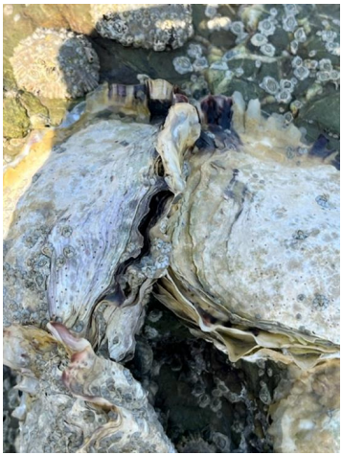
In the UK we have lost 90% of our seagrass meadows in the last 100 years, a state of affairs which if mirrored in full view on land would have raised greater public concern. The restoration of seagrass habitat is once again being championed by the Cornwall Wildlife Trust in cooperation with Cornwall Council and initial results have been described as “incredible and exceeding expectations”.

If you would like to join with other volunteers in making a difference for nature, please view Cornwall Council's Nature Recovery Strategy which is available online and also check out the volunteer opportunities available with the Cornwall Wildlife Trust
https://cornwallwildlifetrust.goassemble.com/opportunities/results
Close up of Pacific Oysters

‘Happy Feet’ Foot Care Event and
MyFeock Community Hub Wellbeing Survey
On Saturday 10th October the MyFeock Community Hub provided a health care and wellbeing event on Foot Care with an informative, enlightening talk from Diane Trebilcock (former Practitioner) followed by a thoroughly engaging and interesting demonstration on how to care for our feet from Wendy Johnson (Foot Health Practitioner). The event was timed to coincide with the flu vaccination clinics at Carnon Downs Surgery to attract ‘footfall’ and offer refreshments post vaccination. The event was well received and provided an opportunity to launch our survey on what type of community events and health and wellbeing topics residents would be most interested in learning about.

Useful information on foot care:
Podiatry leaflets, videos and referral forms available on www.cornwallft.nhs.uk

Podiatry Advice and Urgent Hotline 01209 318093 Mon-Fri 8.30am – 4.30pm (out of hours use NHS111)

Self-care gadgets are available through Tremorvah Industries, Threemilestone, and the Treliske site Mobility Centre.

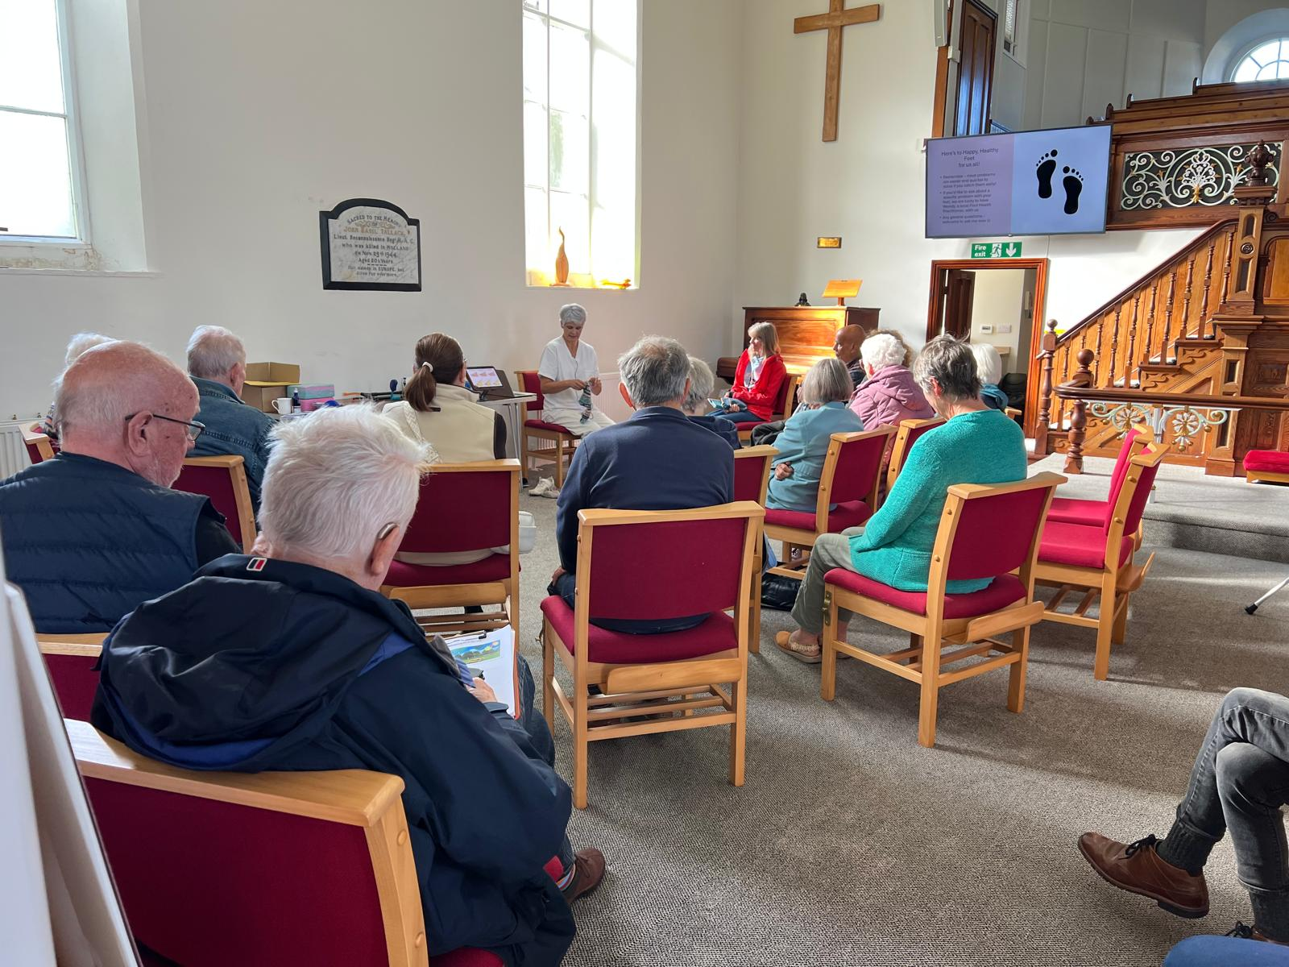

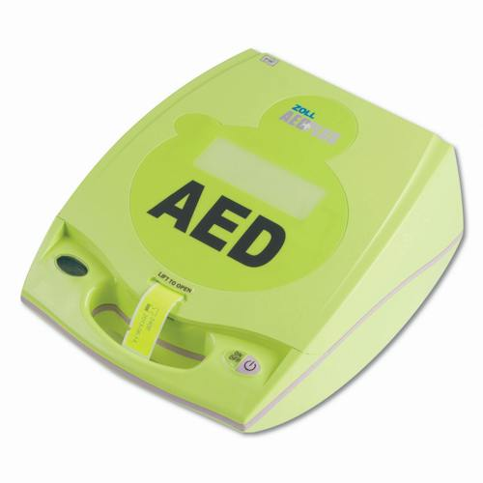
Public Access Defibrillators
There are a number of public access defibrillators located around the parish to be used in an emergency. The Parish Council have installed and manage some of these, together with other local organisations who have kindly also provided defibrillators for public use.

A big thank you to local resident Sue Cooper who for the last few years had been regularly checking the defibrillators to ensure they are operational and in good order. This ensures we can keep The Circuit website updated which is used by the South West Ambulance Service to direct 999 callers to the nearest defibrillator in the event of an emergency.

It is vitally important that the information on the website is kept up to date, if you do unfortunately have to collect a defibrillator in an emergency but haven’t been instructed to do so by the Ambulance Service, when you are able, please get in touch with the Parish Council. This is so that we can update the website that the defibrillator is unavailable so the emergency services do not direct someone to a defibrillator which is missing as it has been taken to help someone else and can direct them to the next closest available defibrillator.

Devoran
- Red phone box at the bottom of Market Street in Devoran, TR3 6QA (beside the Village Hall and bus stop) ​
Feock
- Please note new location: At the entrance to Retallack Playing Field (Feock Park) TR3 6RG beside Parish Council noticeboard. This defibrillator was previously at Ferris Garage but following their closure has been moved to the park​
- On the outside wall of Twitterings, Trolver Croft, TR3 6RT.
- Feock Church & Community Hall car park, TR3 6SA
- ​Loe Beach, TR3 6SH.
- The Punchbowl & Ladle Pub, Feock, TR3 6QY - outside wall in car park.
- National Trust Trelissick, TR3 6QL
Carnon Downs
- Red bookswap phone box on Forth Coth (just outside of the dentist) in the centre of Carnon Downs.
- Carnon Downs Motorhome & Caravan Club campsite, TR3 6JJ
- Carnon Downs Bowling Club, TR3 6HX (not available 24 hours a day)
Point
- In the phone box on Point Green just up from the Quay, TR3 6NL

​Learn CPR in 15 minutes for free with RevivR from the British Heart Foundation
CPR is an emergency lifesaving procedure, performed when the heart stops beating, often called a cardiac arrest. It is necessary to save the life of someone in cardiac arrest.

Each year over 40,000 people have an out-of-hospital cardiac arrest in the UK. Less than 1 in 10 survive. Giving CPR promptly and using a defibrillator can more than double the chances of survival.
Learning CPR with RevivR is free, simple and convenient and takes just 15 minutes. All you need is a cushion and your phone or tablet.

Follow this link to start the online training https://revivr.bhf.org.uk/

BT: Landlines are going digital
By January 2027, the old copper telephone network will be switched off and replaced by new digital phone lines that use your internet connection.
Over three million BT customers have already moved to digital landlines and are benefiting from a safer, more reliable service, with more than 91 million scam and spam attempts on customers blocked in the last year alone.
British broadcaster, Clare Balding, is leading a new BT campaign with a call-out to the remaining analogue landline customers to act when contacted by BT or their provider. She says, "When your provider gets in touch, it's vitally important you act to ensure your landline services keep running smoothly. If you don't respond, the services you rely on could be disrupted."
The campaign comes as new research reveals that 63% of UK adults admit to delaying essential tasks – from booking doctor appointments to car MOTs - and almost one in three (29%) say they have ignored or delayed responding to messages from essential service providers, often assuming things will continue as normal.
Together, the campaign and research highlight the importance of acting now to prevent disruption to customers' service as the deadline approaches.
Support is available every step of the way:
- The majority of customers can switch at no extra cost.
- Customers can keep their existing number and the same phones they use today.
In addition to this, protecting customers with additional needs remains BT's top priority. BT continues to strengthen safeguards, including working closely with local authorities, telecare providers, charities, and government as part of the Public Switched Telephone Network (PSTN) Charter of Commitments, helping to ensure those with additional needs are identified and supported safely through the transition, including free in-home engineer visits and provision of backup power solutions to help customers make calls during power cuts.
Parish and town councils can play a vital role in helping residents prepare for the move from analogue to digital landlines. As trusted local organisations, parish and town councils are well placed to raise awareness through newsletters, websites, noticeboards and community events, helping to ensure people understand that they do not need to take action until contacted by their provider, but should respond promptly when they are.
Parish and town councils can also help identify and support vulnerable residents, including older people and those who rely on telecare services, by signposting them to available support and encouraging them to register for additional assistance where needed, for example by registering for support on the BT website. By working with local community groups and service providers, parish and town councils can help ensure no one is left behind during the transition and that residents continue to stay connected safely and reliably.
Customers do not need to take action until they are contacted directly. When they are, they will receive clear guidance and at least four weeks' notice to make the switch.
Further information and support are available on BT's Connected Together site, or by calling 0330 1234 150.

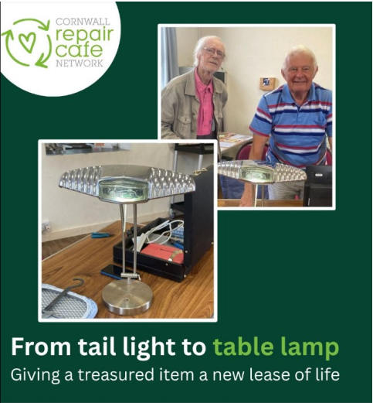
MyFeock Repair Cafe @ The Hub Carnon Community Methodist Church
Don't throw it away – let us take a look!

An old Daimler tail light has been given a bright new purpose thanks to Richard, one our volunteers at Carnon Downs Repair Café.

Joe had kept the number plate light from a much-loved car and wondered if it could be turned into something useful. With Richard's help, it was transformed into a unique rechargeable desk lamp.

It's a wonderful example of how a little creativity, some repair know-how and a community spirit can give treasured items a second life.

A huge thank you to all our amazing volunteers like Richard who help make stories like this possible at the Repair Café.
Our next MyFeock Repair Café is taking place on Tuesday 24th November, from 10.00am to 11.30am at The Hub Carnon Community Methodist Church Bissoe Road, Carnon Downs, and then on every last Tuesday of the month (except for December). The November Repair Café is our last one before Christmas and Citizens Advice will be attending this café to tell you more about the help they can offer, they are also looking for volunteers from our community too so why not come along for a chat?
Bring along your broken or well-loved items and our friendly volunteer repairers will do their best to help give them a new lease of life. From small household items and clothing repairs to technology, toys and more, we're here to help reduce waste and save items from landfill.
Donations are welcomed to cover the cost of repairs and refreshments, ensuring we can continue offering this valuable community service.

We have pop up stalls from local organisations and charities at the Repair Cafe, you can even check your blood pressure whilst at the Repair Café by using the blood pressure machine, full instructions and guidance will be provided to enable you to use it. If you’re a local organisation or charity and would like to attend please get in touch with Cathy via myfeock@feockparishcouncil.gov.uk

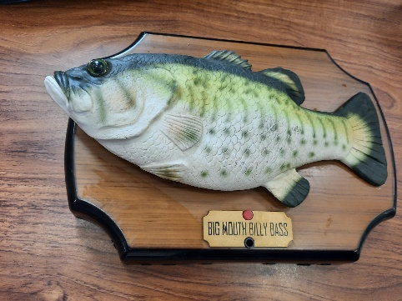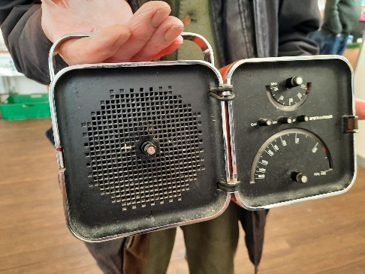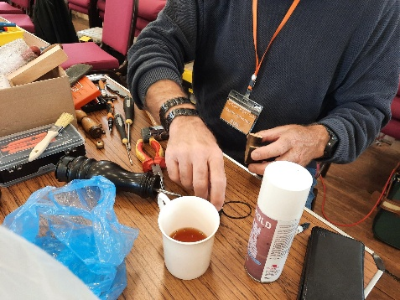
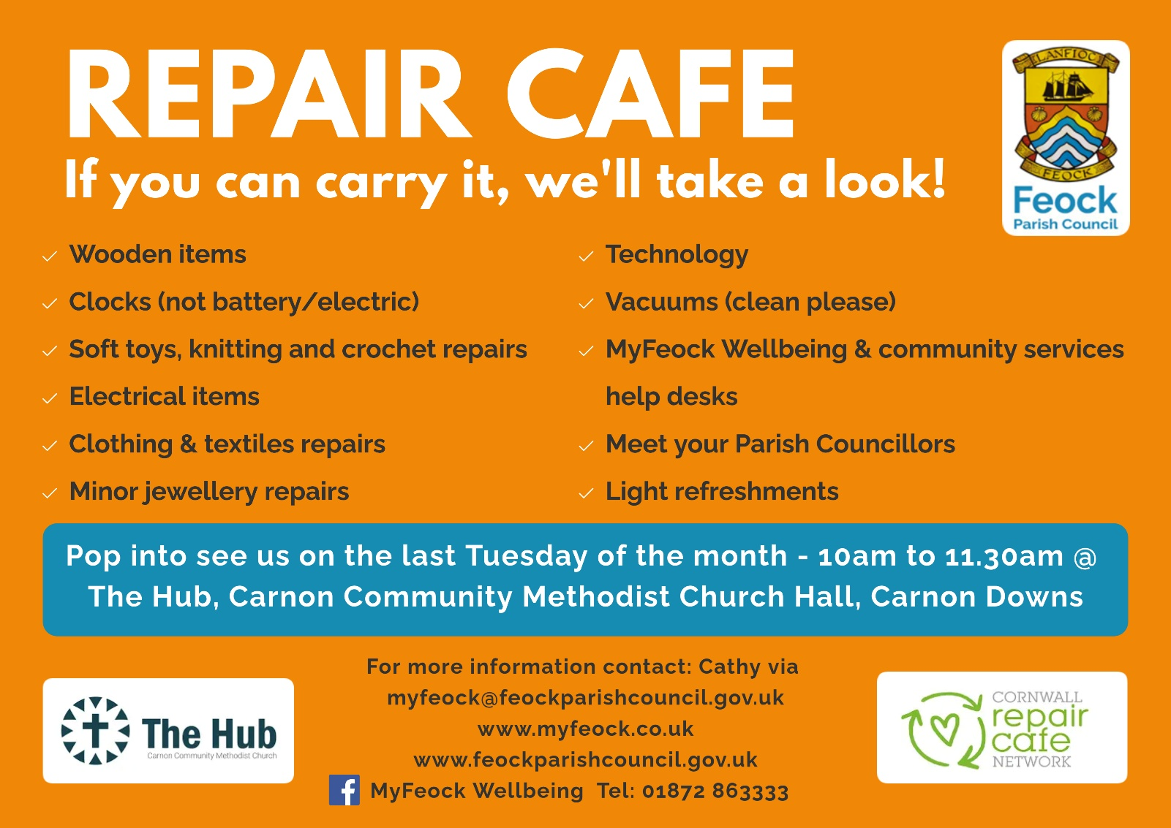
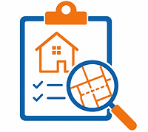
Planning in the Parish
The Parish Council submits consultee comments on planning applications within the parish in line with our Neighbourhood Development Plan (NDP), taking into account any comments received from neighbours and other interested parties.

Details of all planning applications received from Cornwall Council for consultee comment are published on the Parish Council's website and Facebook page as they are received
www.feockparishcouncil.gov.uk/current-planning-applications

We also publish weekly updates on our Facebook page showing the planning decisions made by Cornwall Council on applications within the parish.

Parish Councillors welcome comments from residents and other interested parties, which are taken into consideration when deciding the Council's consultee response. However, it is important that you also submit your comments directly to Cornwall Council, as it is the local planning authority and is responsible for making the final decision on each application.

Even if you have emailed your comments to the Parish Council and/or attended a Parish Council meeting to express your views, you should also submit them to Cornwall Council. Further information on how to respond to planning applications is available on their website: https://www.cornwall.gov.uk/planning-and-building-control/planning-advice-and-guidance/how-to-respond-to-planning-applications/

To help you stay informed about planning applications in your area, we recommend signing up for planning alerts through Cornwall Council's online planning portal.
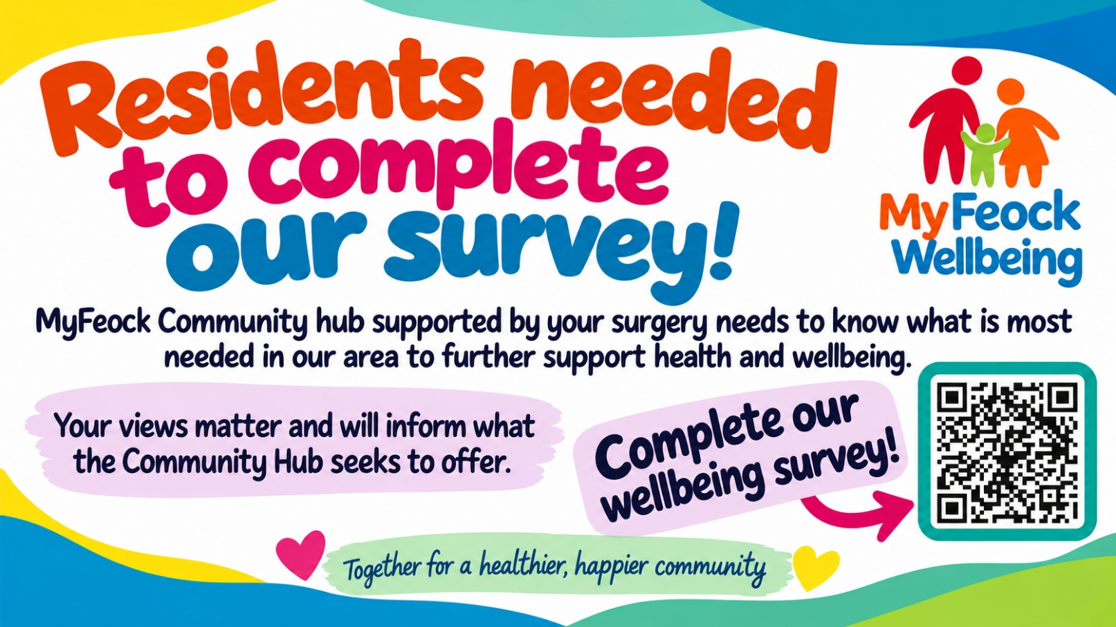

Parish Councillor vacancies
Are you passionate about our local area? Do you want to help shape the future of our parish?
Do you care about our local community? Would you like to have a say in the decisions that affect where we live?

Feock Parish Council is currently looking to appoint four new Parish Councillors – two for Devoran Ward and two for Feock Ward – and we'd love to hear from people who are passionate about making a positive difference. Being a Parish Councillor is a rewarding way to serve your community. You'll help make decisions on local issues, represent residents' views, and work with fellow councillors to improve life across the parish.

No previous experience is required – just enthusiasm, common sense, a commitment to your community, and the ability to attend one Parish Council meeting each month. Although the vacancies are ward-based, many of the issues the Council considers affect the whole parish, so you don't necessarily need to live in the ward you represent.

If you're interested, we recommend attending a Parish Council meeting before applying to get a feel for how meetings are run and the wide range of topics discussed.

Applications are welcomed throughout the year when there are vacancies to fill, with the deadline being the Wednesday before each Full Parish Council meeting. Meeting dates can be found later in this newsletter.

For an informal chat about the role or to find out how to apply, please contact Debra Roberts, Parish Clerk, by emailing clerk@feockparishcouncil.gov.uk, calling 01872 863333, or visiting www.feockparishcouncil.gov.uk

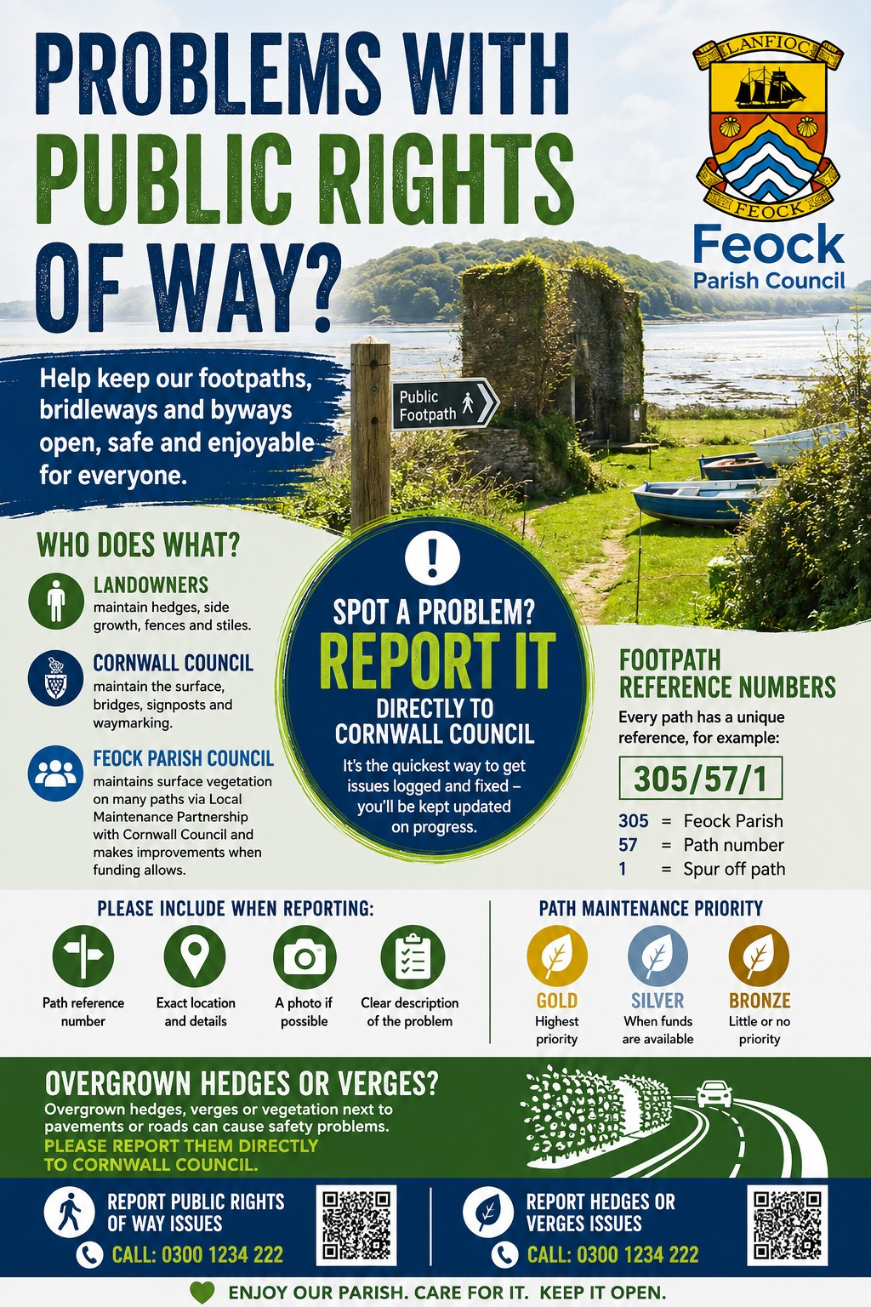
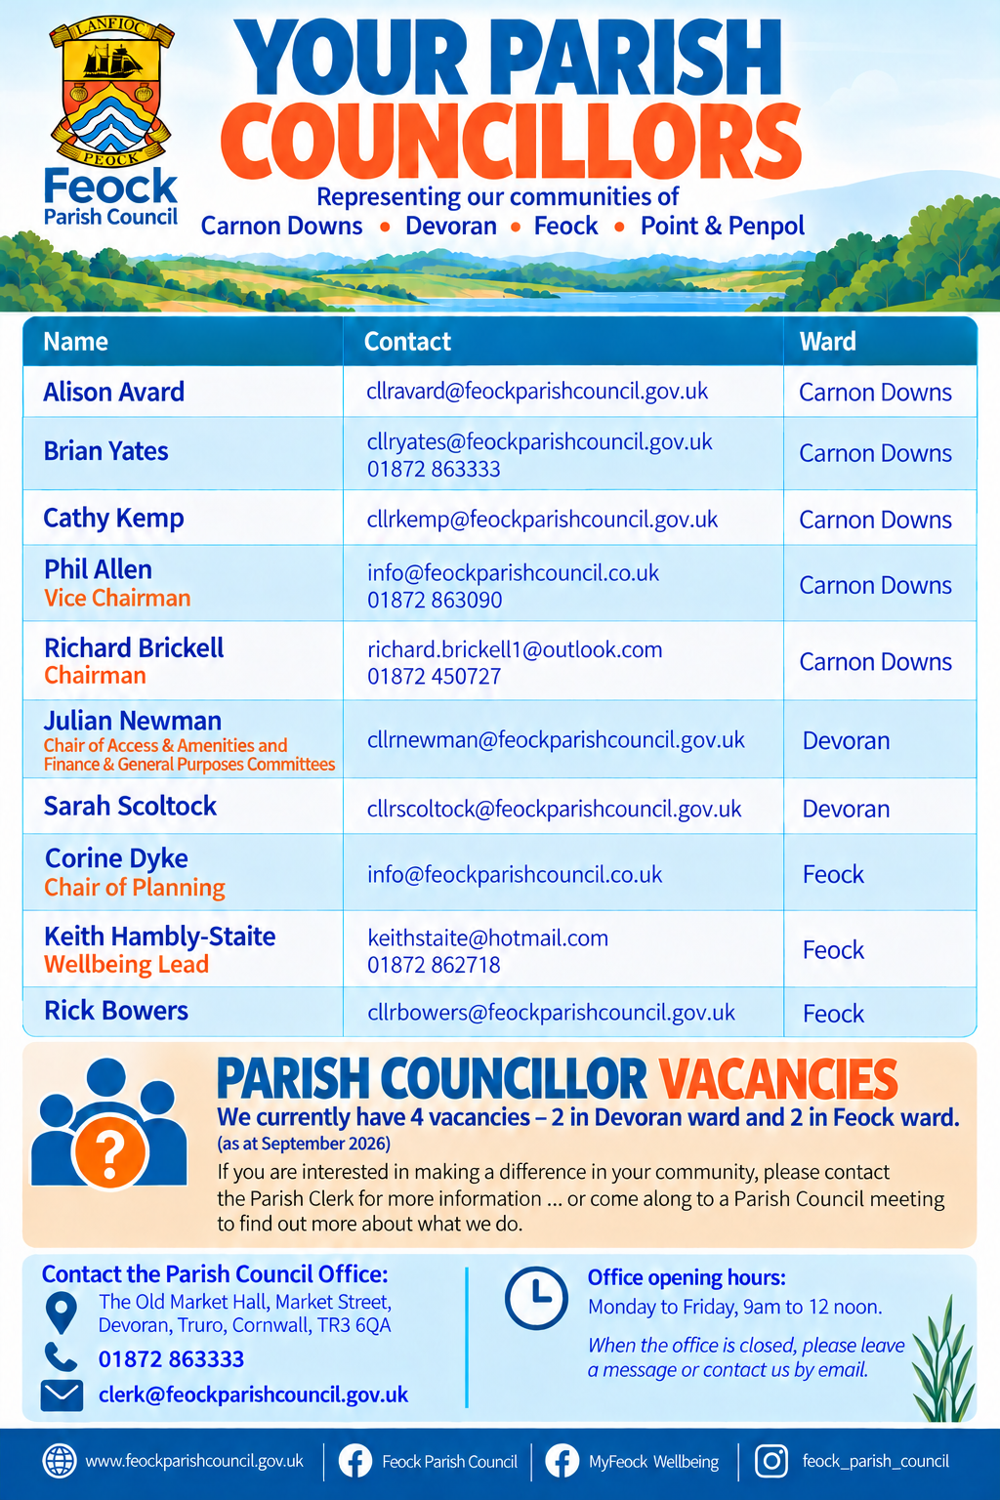

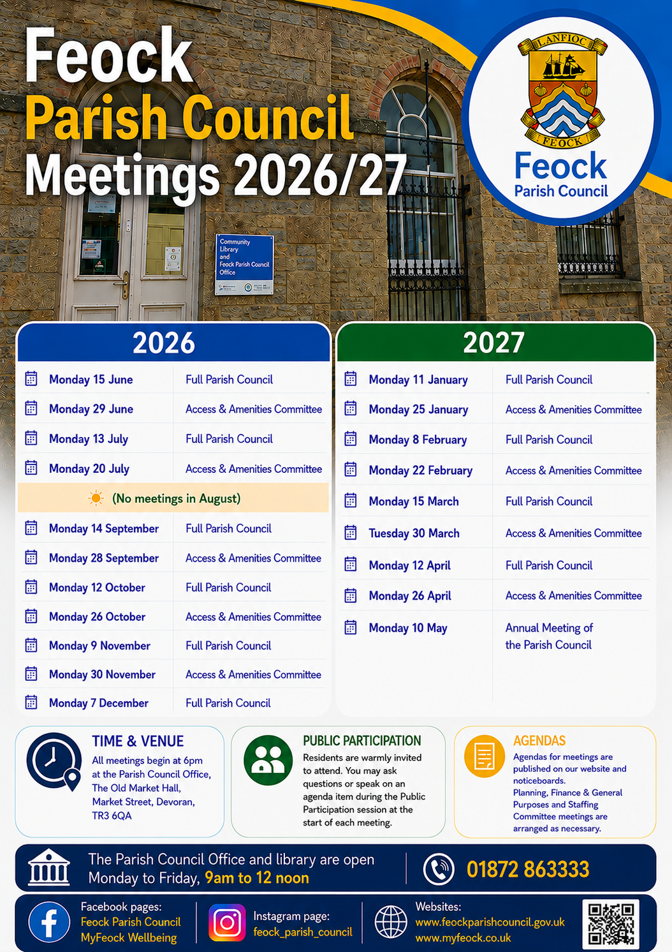

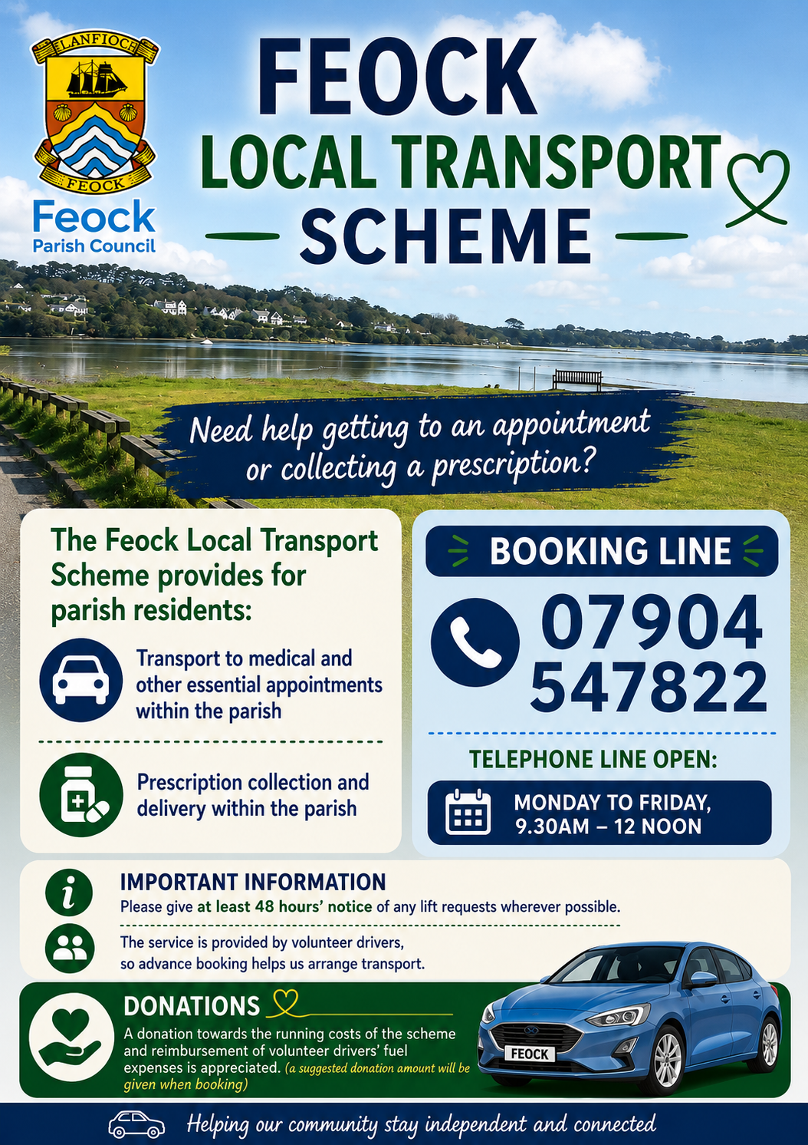

Feock Parish Council, The Old Market Hall, Market Street, Devoran, TR3 6QA

